**Form design Main Project**

**Submitted to**

**Ms.Ginumol Joseph**

**Assistant Professor**

**Amal Jyothi College of Engineering**

* Common Registration Form



* Writers registration continuation

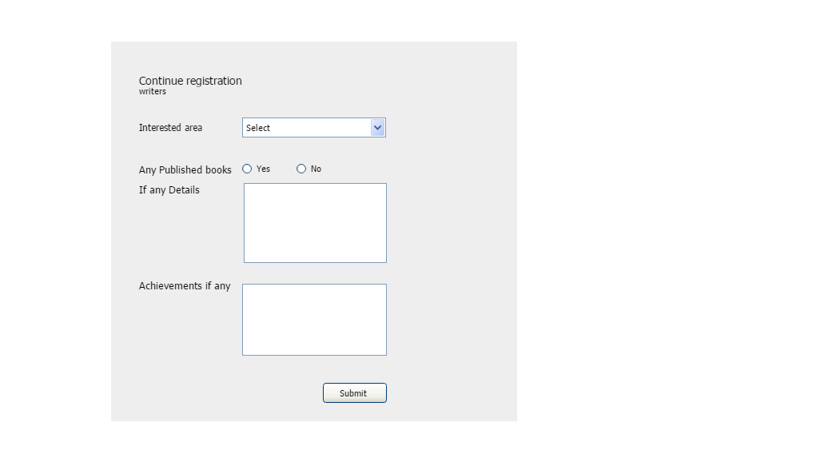

* Book Basket

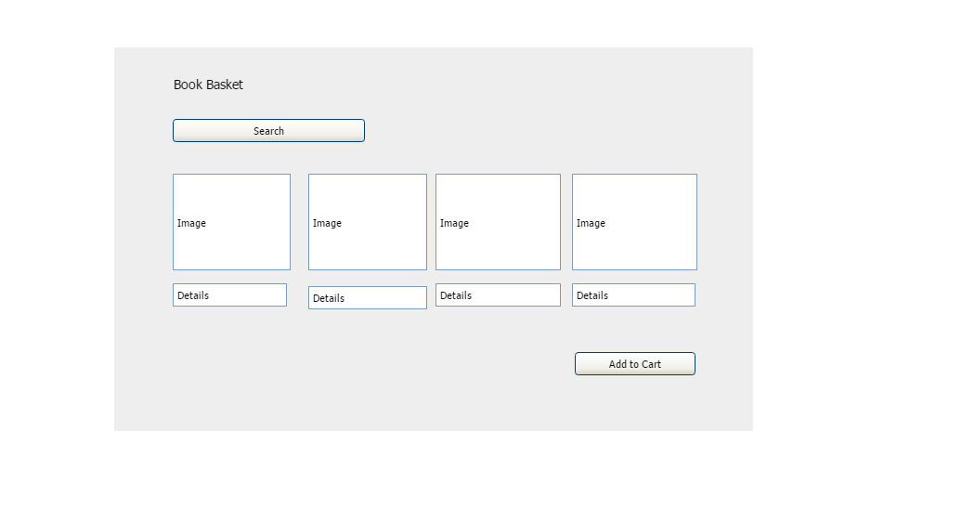

* Book Cart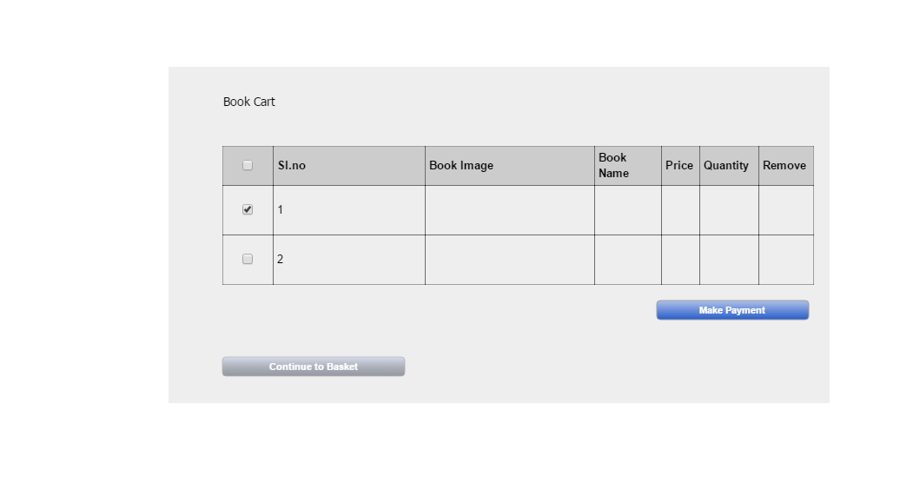
* Designers table

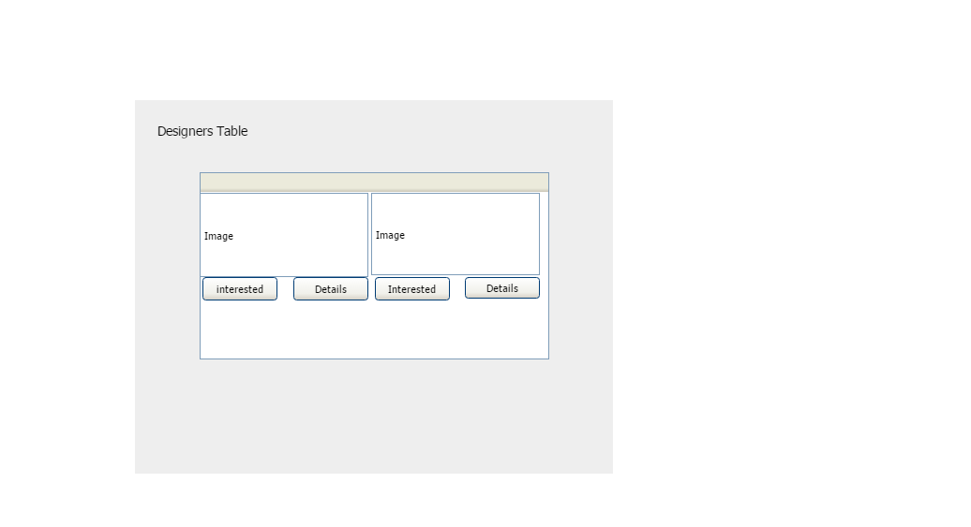

* Login Form

